“Restaurant Readers”-a Clean Fix for Literacy in Sticky Places

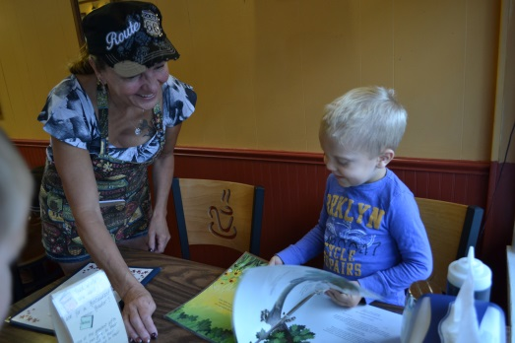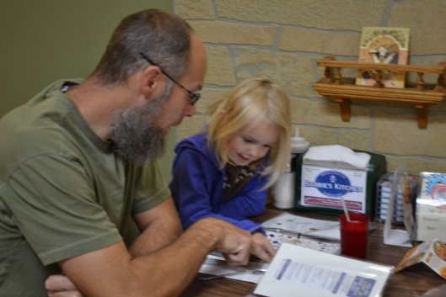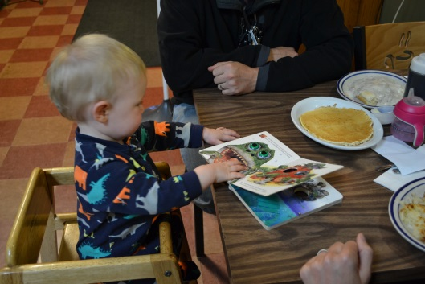

I had the idea a year ago to get books in area restaurants; with the main goal to help parents use the time waiting for food in a positive way. Children can get quite fidgety while waiting for food, and unless you pack an arsenal of activities in your bag, you find your patience quickly disappearing with theirs. Asking friends what they thought of the idea, they loved it, and one suggested that it would be great if they could be washable…and the laminating of a dismantled paperback picture book-the “Restaurant Reader” was born.

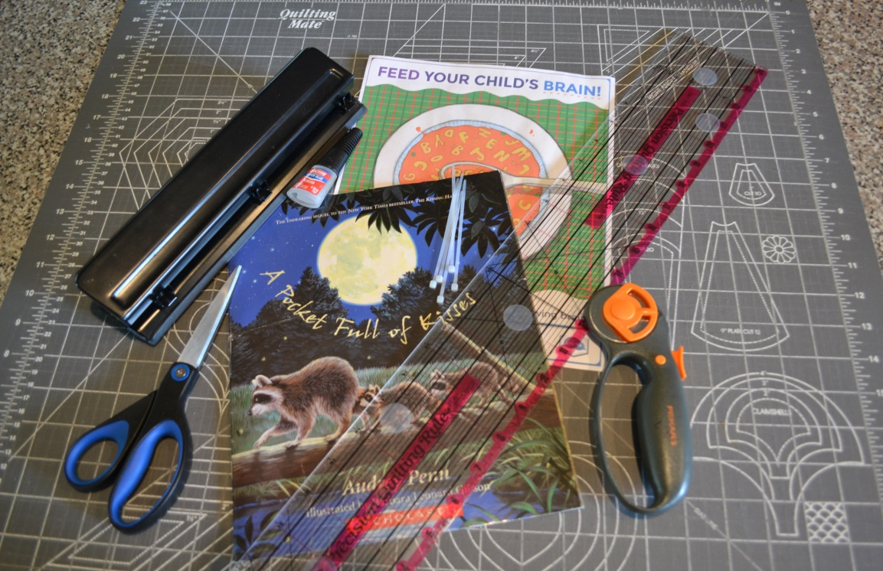
Supplies Needed: A home laminator; the one I use is a Royal Sovereign APL-33OU, is priced at $99.98 at Sam’s Club. Teachers have told me that this does a better laminating job than theirs at school. I use 3 ml laminating sheets, which I usually purchase from Amazon in packages of 100 sheets measuring 12 x 18 inches, for $25.00. These larger sheets make it easier to do multiple pages at a time. I also quilt, so I have a large quilting mat for cutting material on, along with the transparent ruler, and a handheld rotary cutter. I can cut multiple pages at the same time, due to using a transparent ruler, and being able to see what I’m cutting. I use one of the amazing Read Aloud 15 Minutes downloadable graphics to cut to size and glue to the inside cover, they are bright enough for a child to wonder what they are about, and informative for every parent. A label denoting your organization is a nice touch on the front and back cover. I also usually include a label saying something about reading while you wait for your meal, ‘feed your read’, or something catchy. You will also need a hole-punch, zip-ties, superglue, and of course, a book! A variety of books is great-sports, jokes, wordless, ABC, kids of all ages will be reading them. I purchase books from our area Goodwill stores, usually around $2.00 a piece or less, and I also get books in need of a facelift from the teachers. There may be a ripped page or broken binding, and those are easily fixed with use of a laminator.

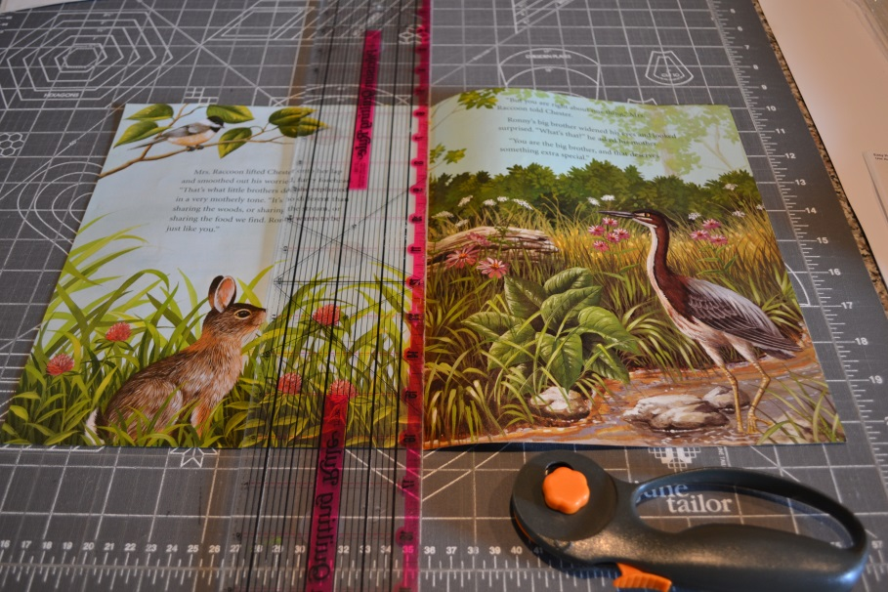

Step 1: Make sure to write page numbers on your book before cutting apart. It is a huge timesaver when reassembling it. Remove the staples from the center of your paperback book. If using a hardcover that has been worn out, I use the title page as the cover, and gently pull the pages from the glued binding. Cutting three pages at a time, cut down the center of the book, until all pages are separated.

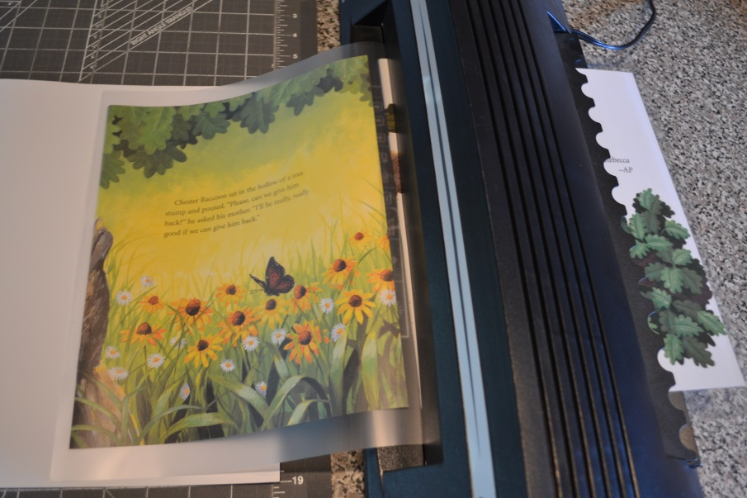

Step 2: Before starting to laminate, give your laminator ample time to warm up. Position your book pages within the laminating sheet. Don’t squeeze pages too close together, they need to have space for you to cut the pages apart and develop a good seal around the edges. Thicker covers may need to be sent through the laminator more than once to remove some of the bubbles around the sides. As you place your book pages on the sheet, make doubly sure that pages are not stuck together. Send your laminating pages through the laminator with the folded side first, careful to have it centered. If it is even the slightest bit crooked, it’s very hard to correct.

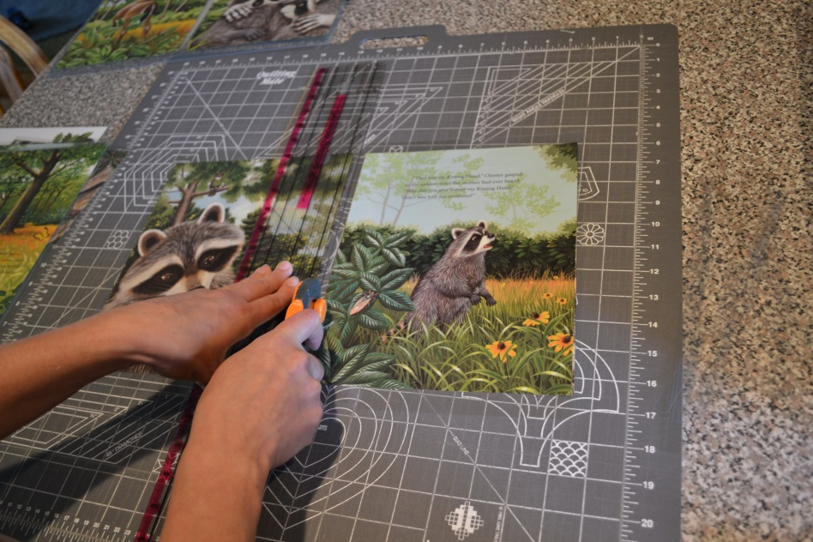

Step 3: Once your sheets are laminated, this is where I find using my quilting ruler really helps. It is transparent, except for lines denoting measurements, and that helps to line up the book edge with how thick of a laminated border you would like. I can’t give you a definitive measurement to leave on the edges of each page, it will vary from book to book. By measuring, you can make sure all of your pages are the same size-which makes for a cleaner looking final product.

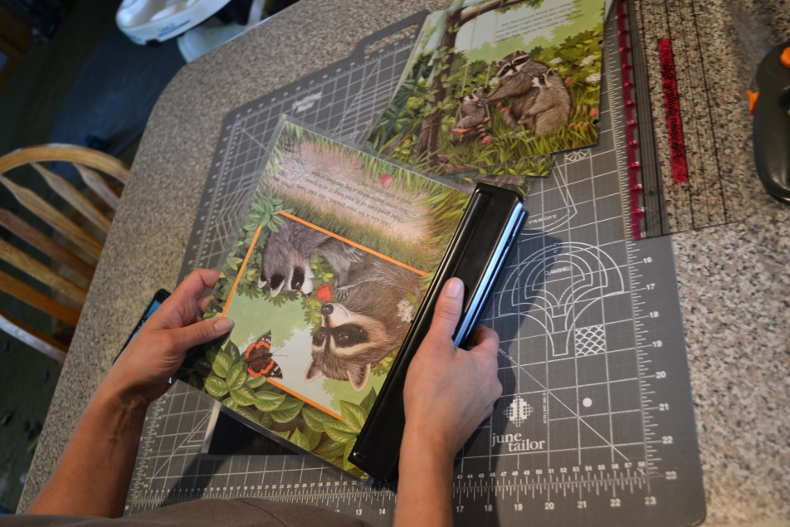

Step 4: When all of your brightly laminated pages are cut, organize them in correct order. Then using a hole punch, punch as many holes as you can fit down the side of the book. Some books will handle three holes, others perhaps only two. Recheck your page numbers (there’s nothing worse than having it all together and finding pages out of order), and slide the zip-ties through the holes. Zip-ties have been the only child-proof means we have found to assemble the “Restaurant Readers”. Children can’t tear them apart once they are locked, and they are washable. As you tighten the zip-ties down, make sure you leave enough slack to make sure the book is easily opened and enjoyed. One last trick that we have learned, it to place a drop of superglue down inside the locking mechanism of the zip-tie, this prevents children making them even tighter. As a final touch, cut the long ends off of the tie.
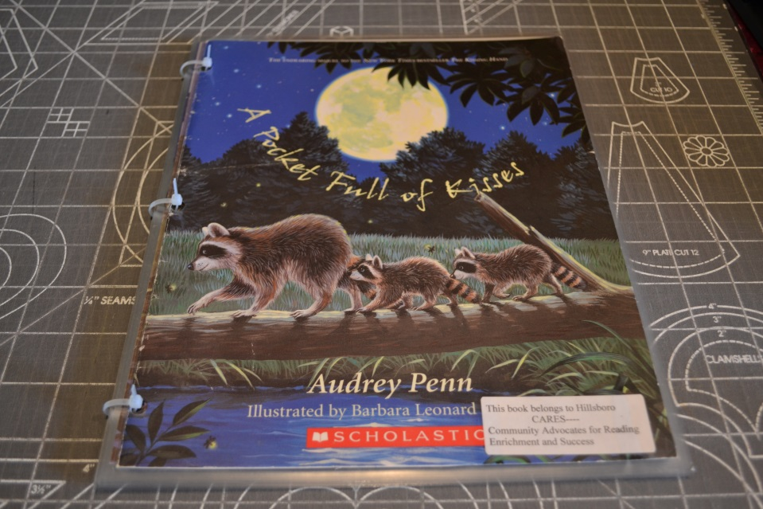

Step 5: Your final product! A bright, shiny, washable, “Restaurant Reader” ready for sticky fingers to anxiously read with parents at a local restaurant!

The Pitch: As I asked our local restaurants, I gave the basic information about how important reading is to the growth of children’s brains. Heads would nod, smiles of understanding would spread across their faces, and one of them even made the point that if they had books to read-perhaps children would make less of a mess on the tables while they waited for their meals. It is a great, educational distraction from dumping salt and pepper containers! It also shows every person that comes in their establishment that they care about the youngest members of their community, and helps create an atmosphere that makes it easier to take your children out to eat. The most effective restaurant at getting books in the hands of children in our community, Barbie’s Kitchen, has an entire shelf of the “Restaurant Readers” that “regulars” can go grab a book as wanted. Barb takes your order of food, then brings a pile of books back for children to read while they wait for their meal to arrive. That extra step of bringing a book to the table for the child seems to make a huge difference, especially to new patrons. “Restaurant Readers” feed your need to read!

